Erik Johnson

MSc Global Sustainable Cities

L2972 Understanding and Modelling Cities

Phase 1. Collecting and Summarizing Urban Data

Global city selected for analysis:

Glasgow, Scotland, United Kingdom

Policy targeted for analysis:

Introduced in 2017, the ‘Justice in Scotland: Vision and Priorities’ strategy included in the Scottish Government’s Safer Communities Directorate laid out the national objective to reduce crime and build upon earlier policies to improve community safety, accessibility and resiliency. The dates of focus were for years 2017 – 2020. The quoted vision of the strategy is “A Just, Safe & Resilient Scotland,” while the outcomes sought for the strategy are as follows:[1]

* We live in safe, cohesive and resilient communities.
* Prevention and early intervention improve wellbeing and life chances.
* Our system and interventions are proportionate, fair and effective.
* We deliver person-centred, modern and affordable public services.

Glasgow has improved on various measurable aspects of crime and safety relative to historical statistics.[2] Despite trends indicating improvement in certain regards, concerns persist with respect to the data collected and the sought outcomes of the 2017 strategy. One such concern is the accessibility of the general population to physical locations of community police stations. According to the Police Scotland website, the Greater Glasgow is composed of eight Area Command regions, with varying numbers of Wards assigned to each. Based on the information available on the website to the general public, there are numerous Wards that either share a community police station with a neighbouring Ward which does not have community police station (or vice-versa), or in some instances may not even have a listed community police station. Whether or not this fact is a factor in the presence of crime or is independent of such could possibly be determined, however it could raise speculation. Also, according to the strategy itself there are seven (7) persisting challenges which hinder full actualization of the outcomes (which include, but are not limited to):[3]

* Increasing inequality and the potential effects on crime and civil/judicial insecurities.
* Adverse childhood experiences and their impact of the judicial system.
* Re-allocation of resources and services to focus efforts on prevention and early intervention.
* Concentrations of crime and disparities in the most deprived neighbourhoods.
* Improving equality and experience within the communities.
* High rates of incarceration in Scotland.
* The disproportional poor health (mental and physical) and wellbeing of individuals in close contact with the criminal justice system.

Intended means to fulfill analysis:

In order to better understand the status and context of this policy (its vision, objectives, methods and challenges) the city of Glasgow and the applicable variables will be analyzed for the period of years both proceeding and during the 2017 - 2020 ‘Justice in Scotland: Vision and Priorities’ strategy. By using the data collected and assessing it against the abovementioned context of this policy, I am confident that the results will show that despite there being positive outcomes sought from the

strategy, persisting trends in crime, health, income and general disparities within communities are present.

Data collected and initial source:

Description: Scottish Index of Multiple Deprivation (SIMD) 2020

Url: https://www.gov.scot/collections/scottish-index-of-multiple-deprivation-2020/

Rationale for use: Survey data for SIMD is collected and published on a regular basis and is relevant to my focus. It provides various governmental-level identifications and relative rankings of various demographic factors. This data will allow me to identify the Data Zones within Glasgow that suffer from respective deprivations. (see example statistical summary below).

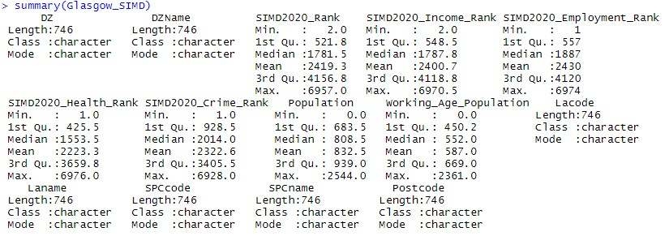

Description: Police Scotland – Glasgow: Local Police Plan 2017 – 2020

Url: https://www.scotland.police.uk/assets/pdf/392813/392817/glasgow-city-localpolicing-plan-2017-2020?view=Standard

Rationale for Use: This is a published PDF document which outlines the policy directives of the Glasgow Police Department for the period of 2017 – 2020. It is relevant to this analysis because aside from being sourced to the city of selection, the period of time mirrors the Justice in Scotland strategy of the Scottish Government.

Description: Police Scotland – Greater Glasgow: Your Community

Url: https://www.scotland.police.uk/your-community/greater-glasgow/

Rationale for Use: This website proved useful in that I was able to find the physical location addresses for community police stations within the Greater Glasgow region. This information will allow me to compare geographic locations of the stations with their jurisdictional wards. If necessary, the street addresses will be able to be used in the Geocode function in GIS software to represent on maps of Glasgow (which I was unable to locate GIS datasets of police stations in Scotland – only in England and Wales).

Description: Scottish Index of Multiple Deprivation - Geographic Access to Services Indicators

Url: <https://statistics.gov.scot/resource?uri=http%3A%2F%2Fstatistics.gov.scot%2Fdata%2Fscottish-index-of-multiple-deprivation---geographic-access-to-services-indicators>

Rationale for Use: This is survey data for SIMD collected representing the years 2015 and 2018. The data is broken up by individual SIMD Data Zone. The method of travel is listed by “Car” and “Public Transport.” For the focus of this project, the target will be on public transportation. Despite many individuals within the SIMD demography owning and operating private cars regularly, the decision to focus on public transit was made because it is a representation of community accessibility.

Understanding Data/ Issues arisen:

While this project was hoping to utilize each aspect of SIMD data to better visualize, analyze and evaluate the aforementioned policy, certain variables were unavailable. Within the ‘Geographic Access to Services Indicators’ dataset there were additional “Destination” variables included, however since the locations were primary and secondary schools there was not an associated “Public Transport” survey measurement undertaken. There is discussion to be had regarding the safety of u-18 students that use public transportation to/from schools; while it may be generally agreed-upon that students indeed utilize the public transit system, for the sake of this project this data is unavailable.

The use of this selected data will allow me to review the current status of various aspects of crime and community experience in the Glasgow City area. Hopefully, there will be identifiable Data Zones that are experiencing outcomes from the policy initiatives. To better-understand the data relative to the policy and outcomes sought from this project I have utilized the XLRM framework (see below)

**Policy Levers (L)**

**Relationship in System (R)**

**External**

**Factors (X)**

**Performance**

**Metrics (M)**

Relational continuity between policing, focused improvement to service accessibility within communities and overall SIMD factors leading to targeted policy outcomes.

+ Changes in SIMD Data Zone Rankings.

+ Recorded instances of crime.

+ Education qualifications.

+ Employment/Income

+ Mean travel time to community service locations.

+ Changes in demographic makeup.

+ Uncertainties (i.e. Brexit, COVID-19, etc.)

+ Ebbs in socio-economic culture.

+ Changes in population.

+ Efficiencies between levels of governance.

+ Justice in Scotland: Vision and Priorities strategy (2017).

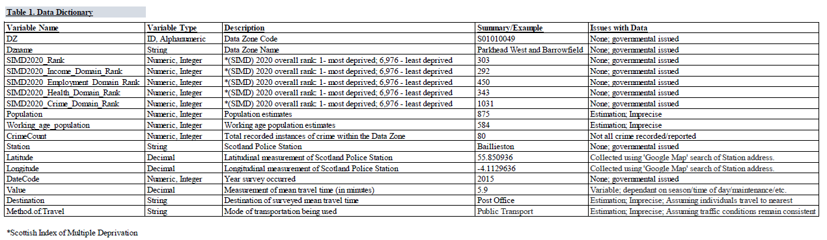

1. Justice in Scotland: Vision and Priorities. https://www.gov.scot/publications/justice-scotland-visionpriorities/pages/3/
2. Police in Scotland recorded a 41% reduction in crime between 2007-8 and 2015-6.
3. Justice in Scotland: Vision and Priorities.